1. Enable Maps JavaScript API.
Go to: https://console.cloud.google.com/google/maps-apis/api-list?project
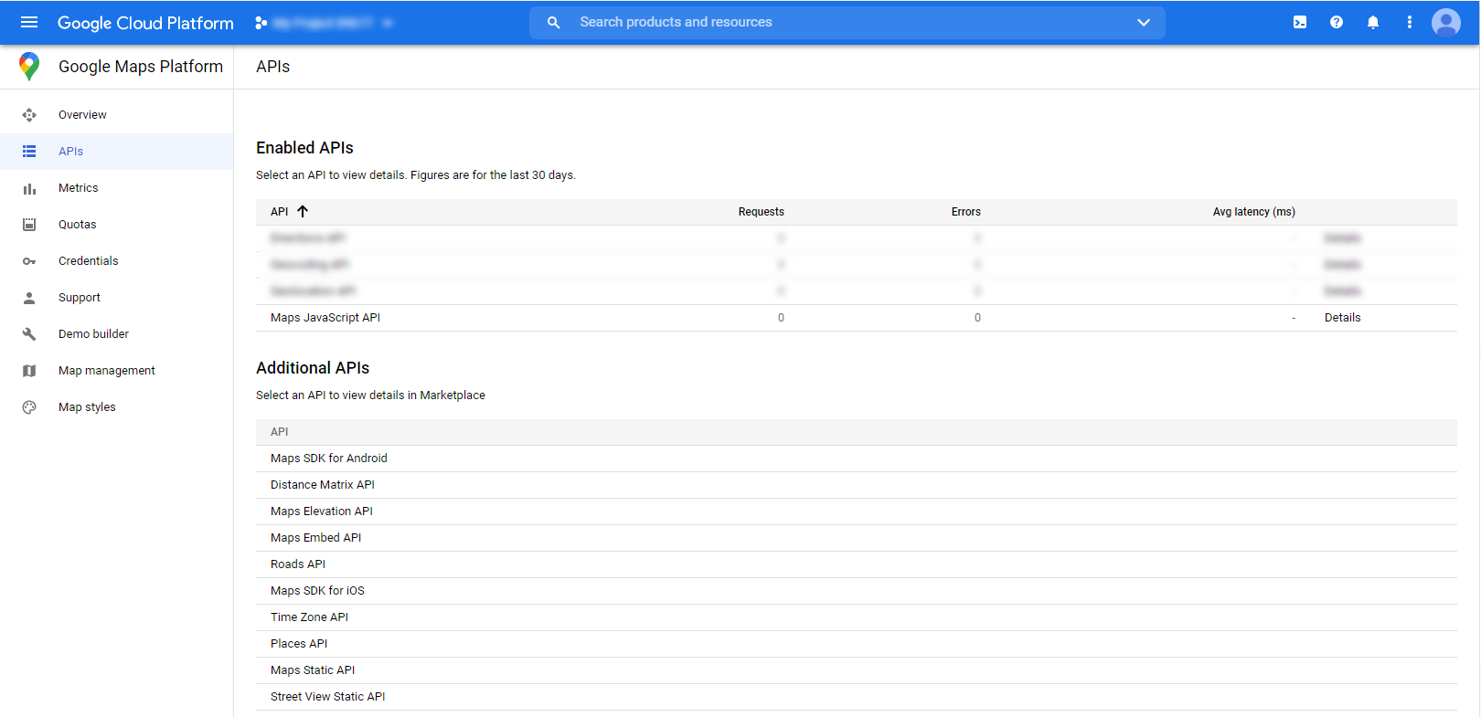
2. Fill Google Maps Settings
