Google Maps for Power BI
Configuration Guide

Contents
Overview 3
Google Maps API Configuration 3
Google Maps for Power BI component configuration 8

Overview
Thank you for installing the Google Maps for Power BI component.
FEATURES:
- Switch to Google Street View when needed
- Use Map to filter results
- Share search results and travel routes
- Minimum number of pushpins in a group (i.e. "start grouping when there are more than 3 pushpins by default)
- Fields in a pop-up (when you click on a pushpin)
- Max number of pushpins to show

Google Maps API Configuration
In order to use Google Maps in Power Bi - Maps JavaScript API must be enabled. Then Google Maps API Key can be generated.
To do that:
1. Go to https://console.cloud.google.com and scroll to the bottom of the left-side menu
2. Select Google Maps -> APIs
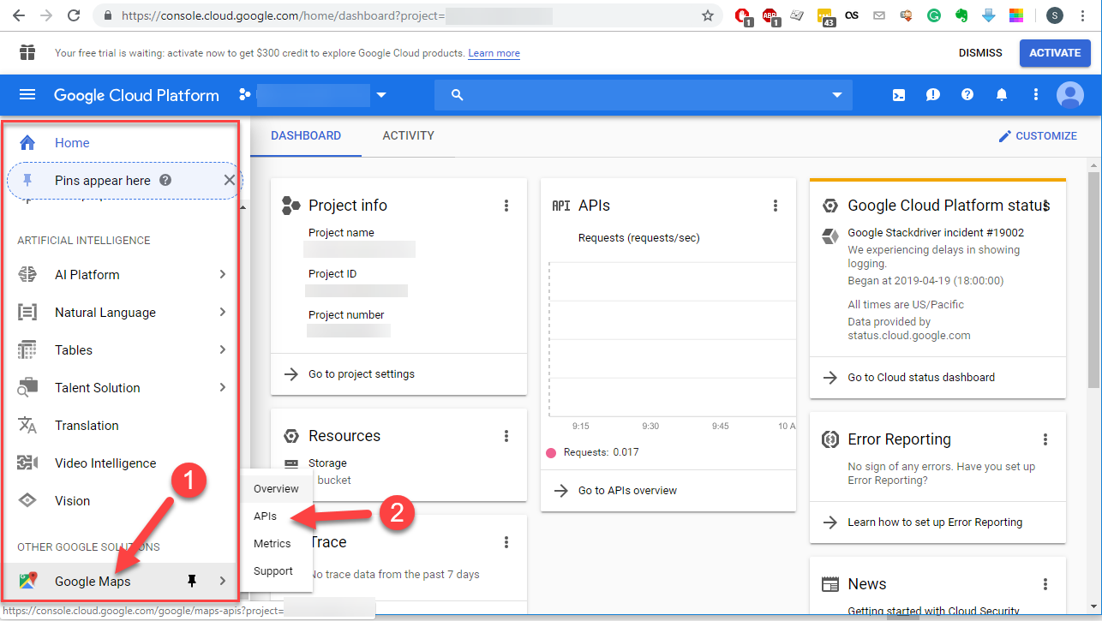
3. Find Maps JavaScript API
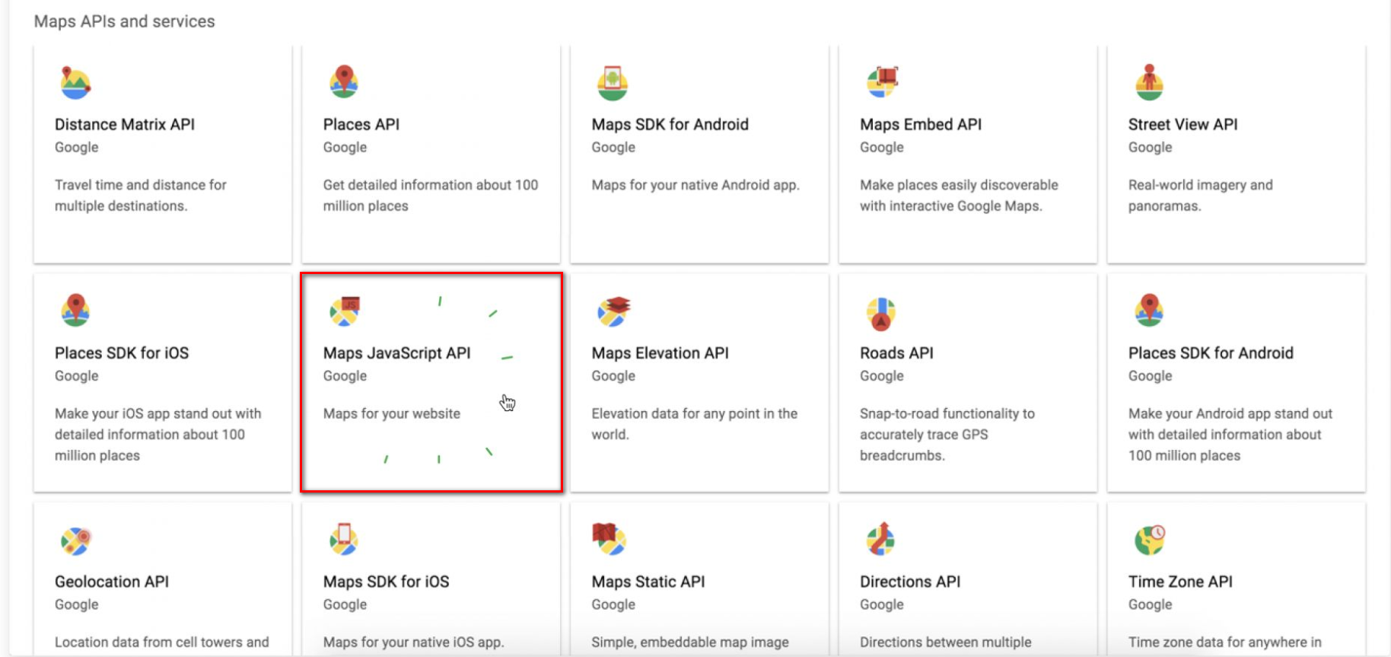
4. Enable Maps JavaScript API
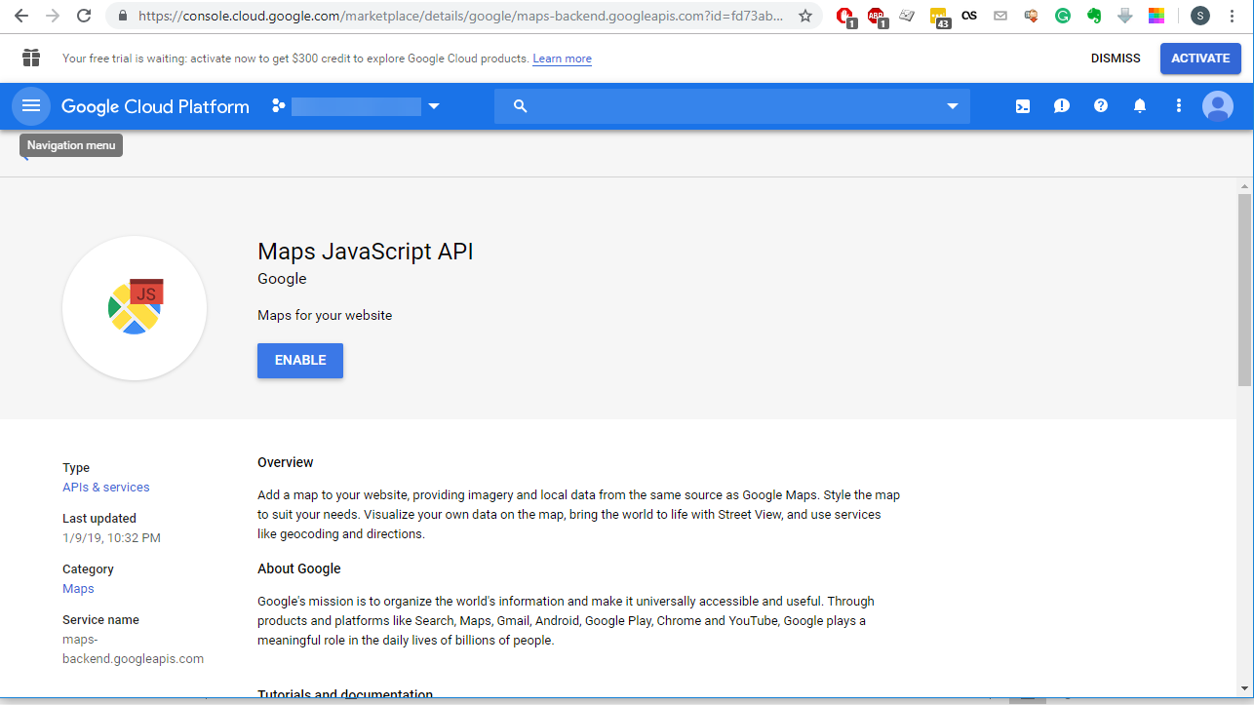
5. Go to Google Maps -> APIs section again
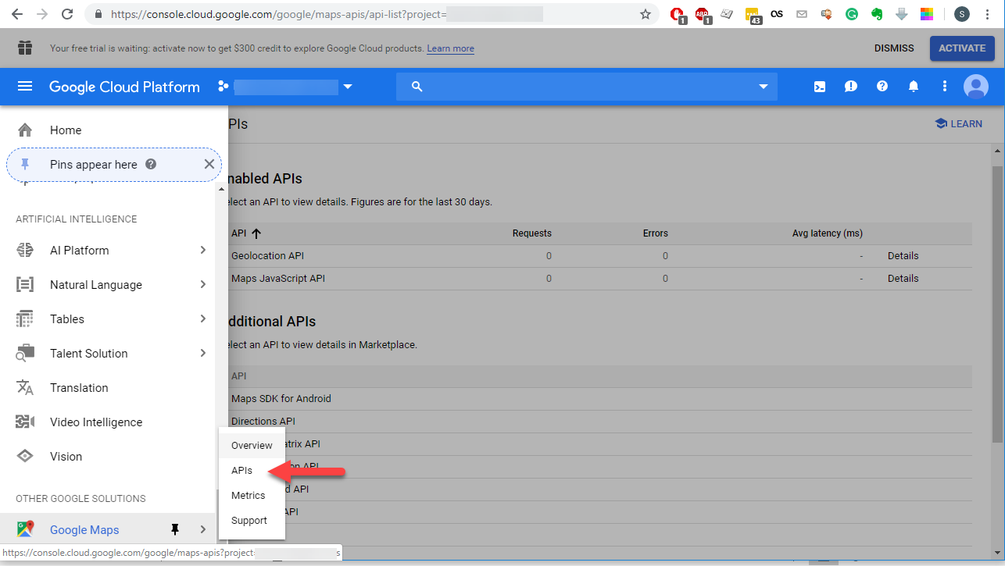
6. Open either Maps JavaScript API
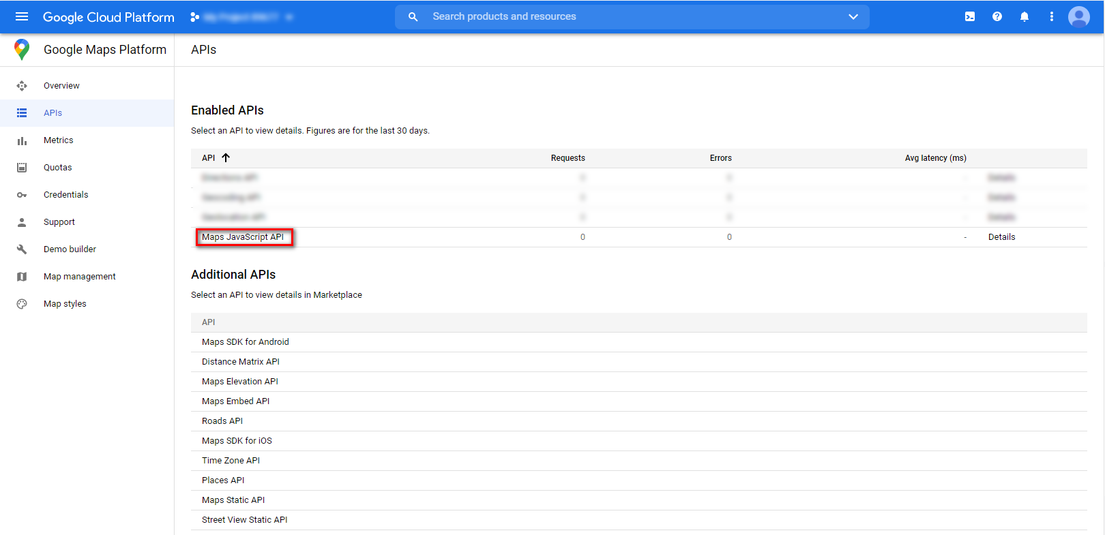
7. Click on Credentials to find API key
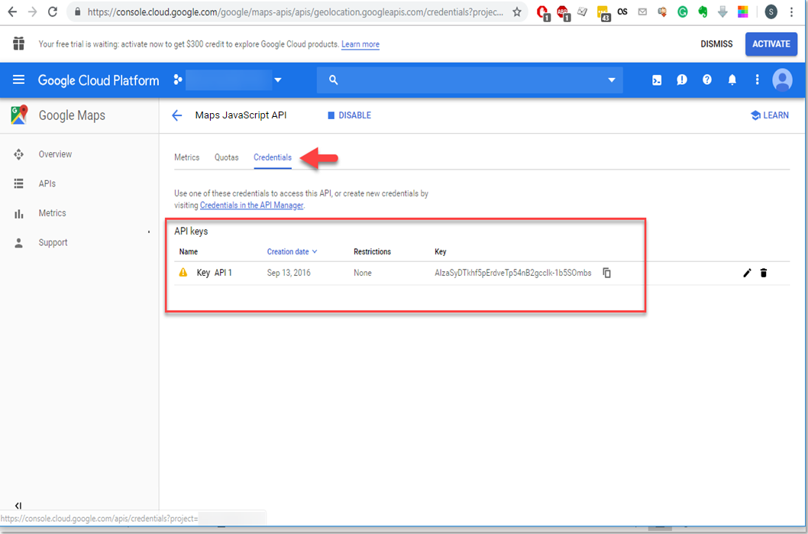
8. If no API keys to display
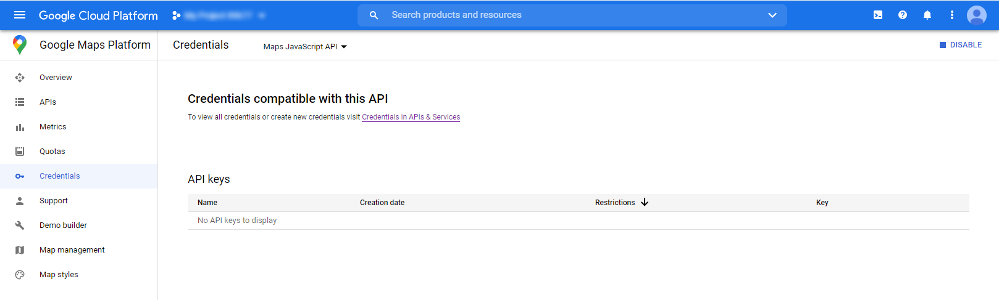

9. Go to the APIs & Services > Credentials page
https://console.cloud.google.com/project/_/apiui/credential
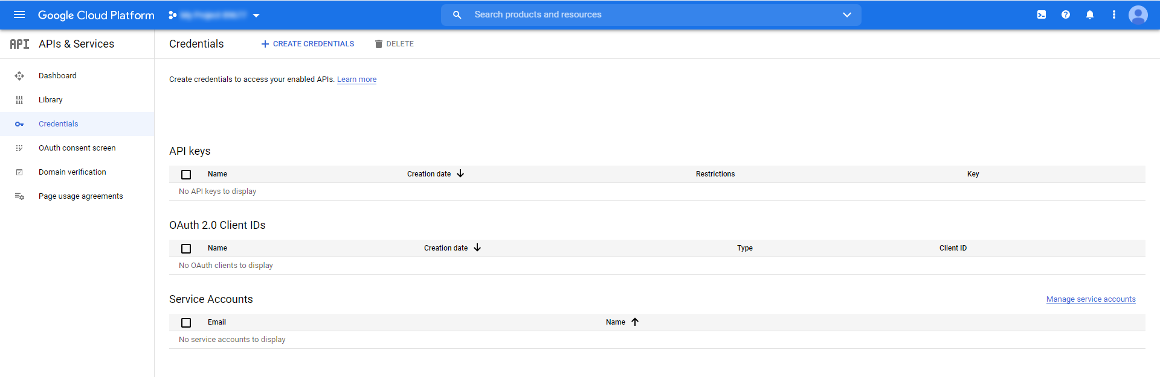
10. On the Credentials page, click Create credentials > API key. The API key created dialog displays your
newly created API key.
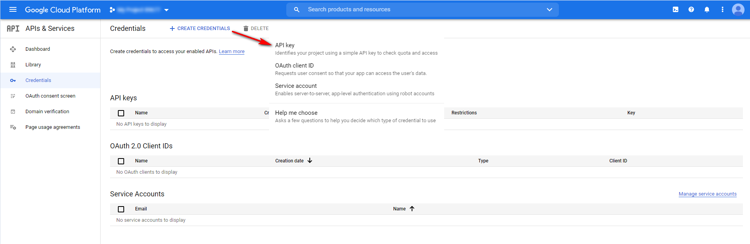

11. Click Close. The new API key is listed on the Credentials page under API keys.(Remember to restrict the API key before using it in production.)

Google Maps for Power BI component configuration
After Google Maps for Power BI component installation few simple configuration steps must be done:
1. Import installed Power BI template: File -> Import -> Power BI visual from file
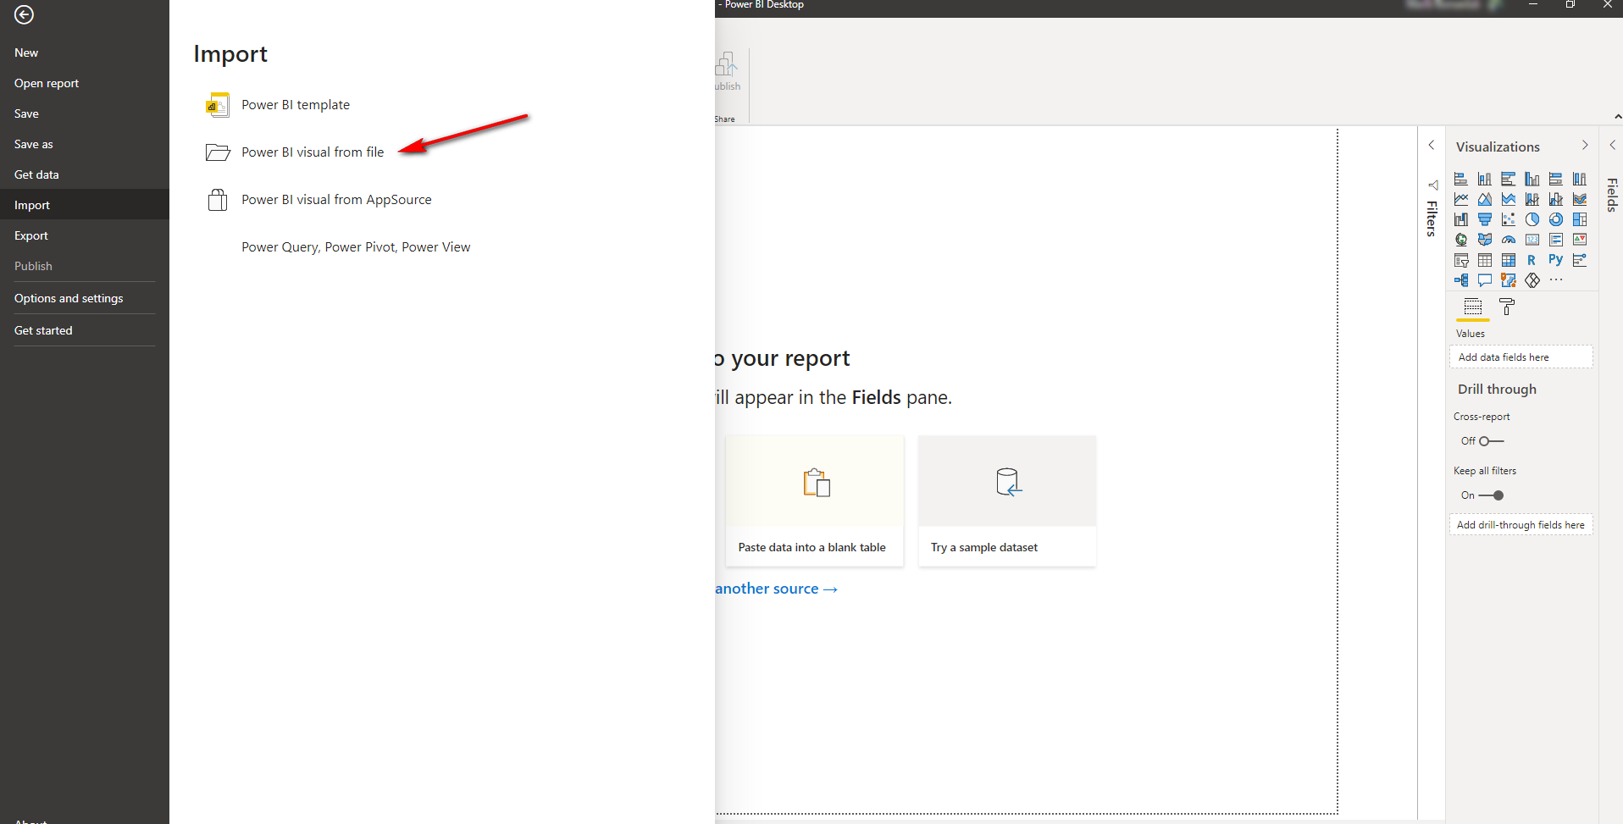
2. Click Ok after importing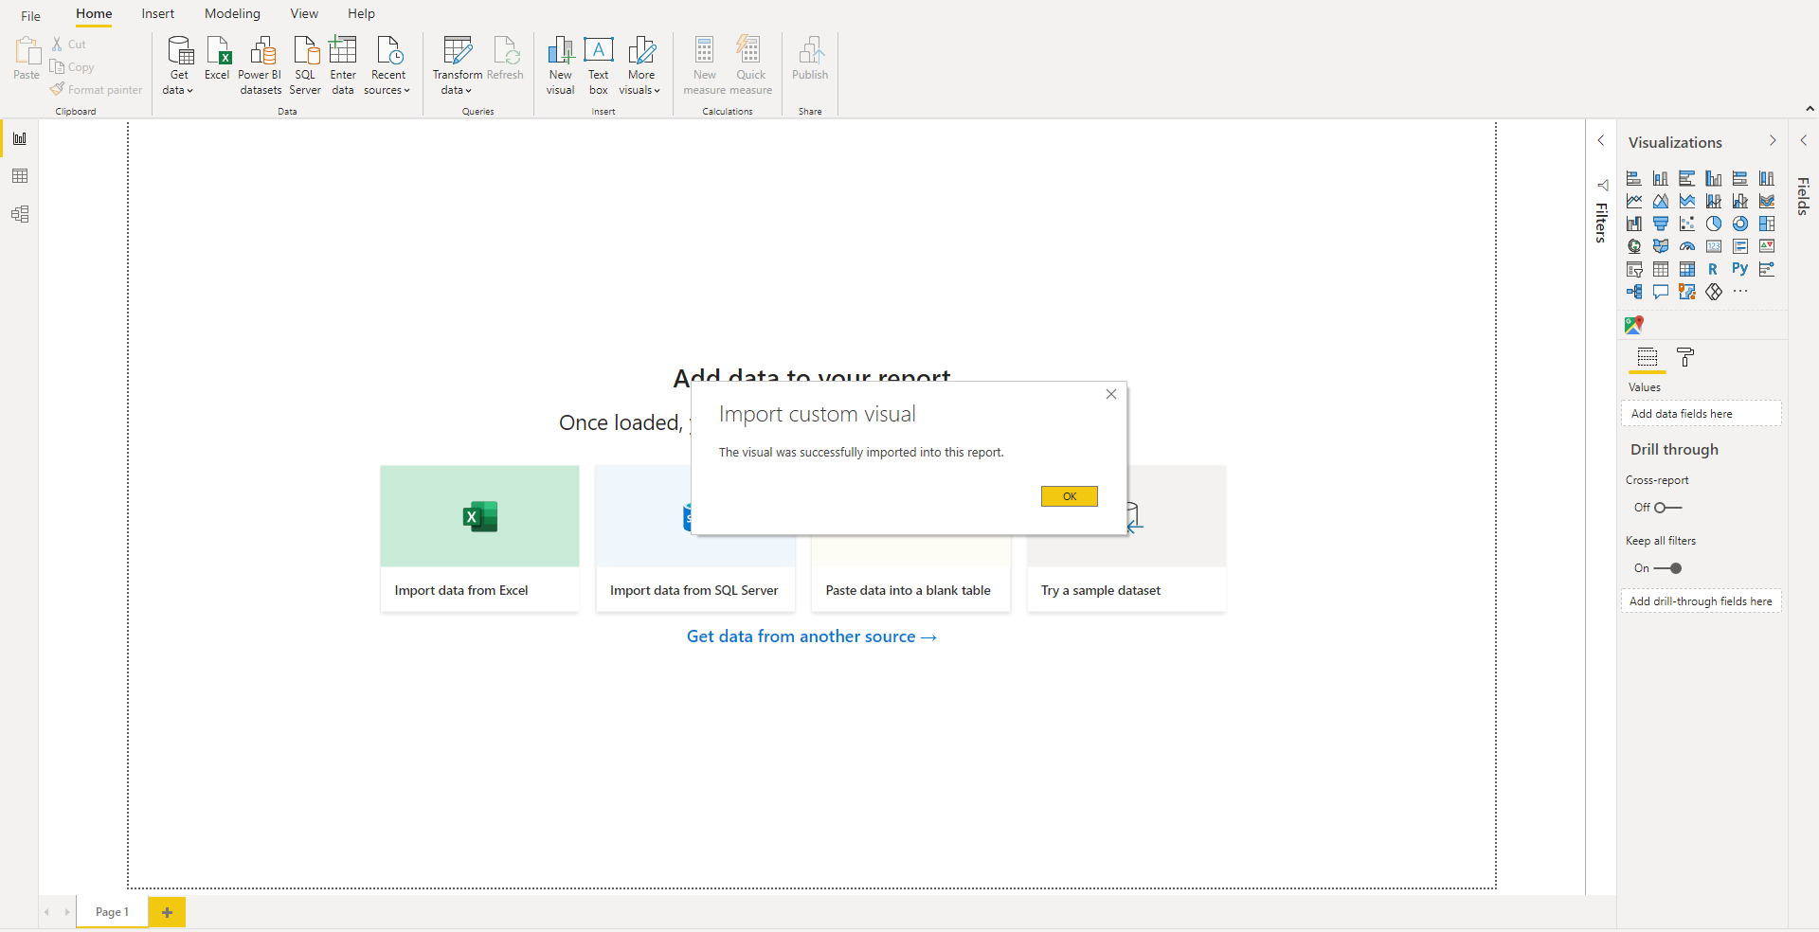

3. Get your data
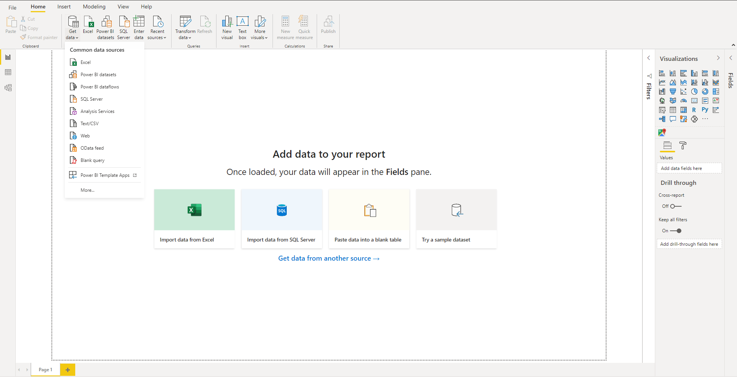

4. Build visuals with your data: Select Google Maps for Power Bi component
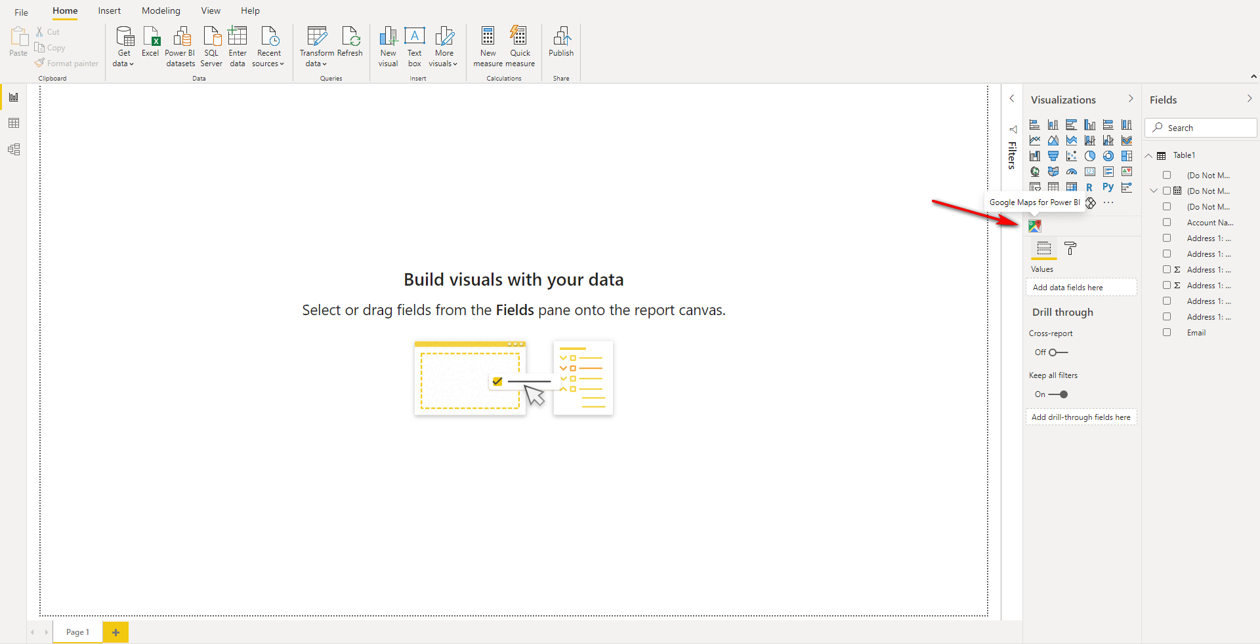
5. Fill the next fields:
- ID: Unique record ID
- Latitude and Longitude: Are the units that represent the coordinates at the geographic coordinate
system
- Tooltips: Select one or more columns from the table to display on the map
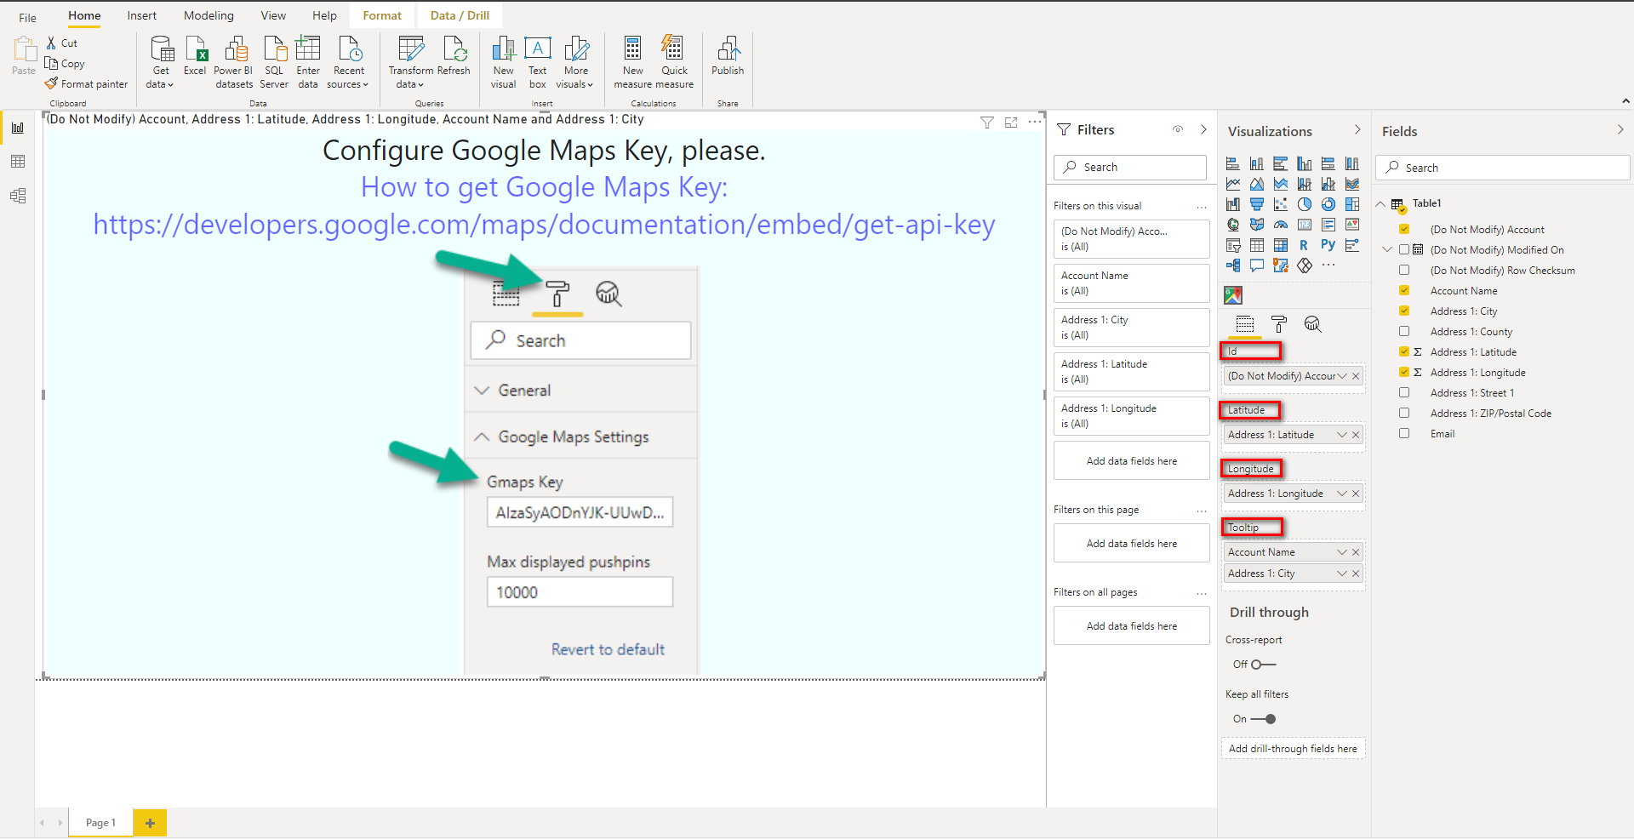

6. Fill Google Maps Settings
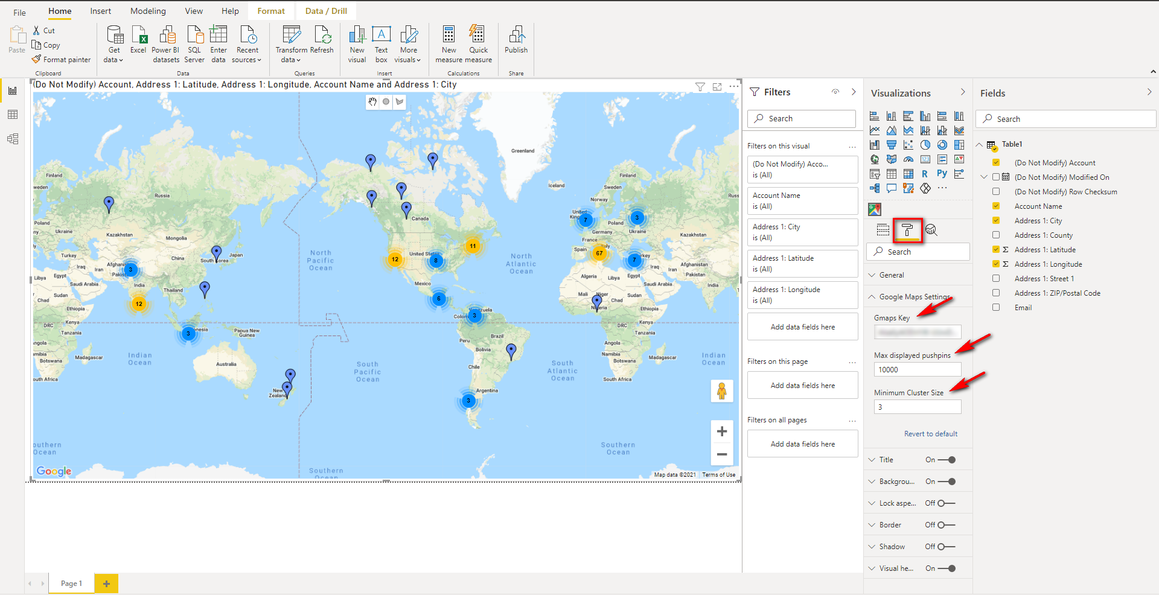
7. Save the current report

